Raj Guest House

Database Design

**List of Tables:**

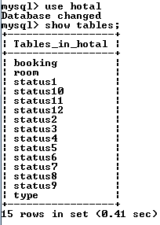

**Table Structure: Room**

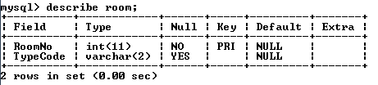

**Table Structure: Booking**

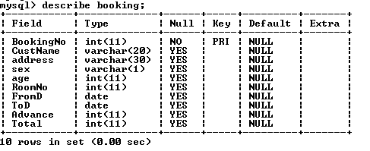

**Table Structure: Type**

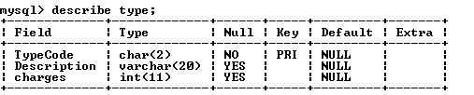

**Table Structure: Status1 … Status12 (12 tables for storing status of 12 rooms)**

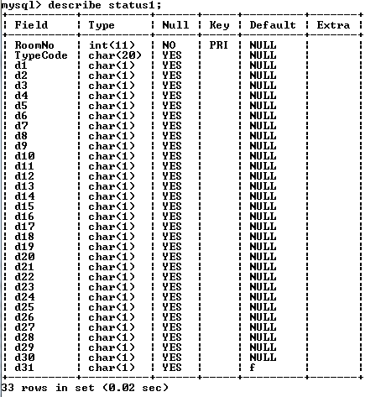

**Restoring Database:**

This package contains hotal.sql file which may be used to create all the tables with initial data.

**Step 1: Open Mysql and make a blank database named Hotal**

Mysql> create database hotal;

**Step 2: Open DOS (Run-> cmd) and give the following commands to restore the table.**

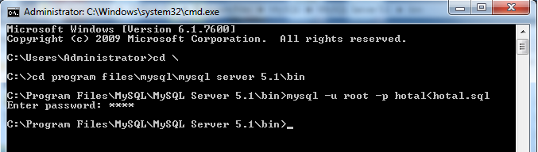

Forms Design & Coding

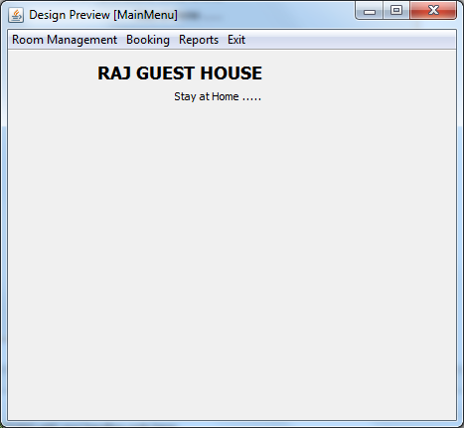

**Menu Structure**

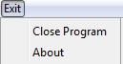

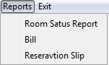

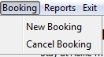

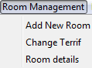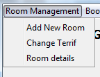

**Form Name: MainMenu.java**

public class MainMenu extends javax.swing.JFrame {

/** Creates new form MainMenu */

public MainMenu() {

initComponents();

}

private void jMenuItem1ActionPerformed(java.awt.event.ActionEvent evt) {

// TODO add your handling code here:

AddRoom rp = new AddRoom();

rp.setVisible(true);

}

private void jMenuItem2ActionPerformed(java.awt.event.ActionEvent evt) {

// TODO add your handling code here:

RoomCharges rp = new RoomCharges();

rp.setVisible(true);

}

private void jMenuItem3ActionPerformed(java.awt.event.ActionEvent evt) {

// TODO add your handling code here:

RoomDetails rp = new RoomDetails();

rp.setVisible(true);

}

private void jMenu1ActionPerformed(java.awt.event.ActionEvent evt) {

// TODO add your handling code here:

}

private void jMenuItem4ActionPerformed(java.awt.event.ActionEvent evt) {

// TODO add your handling code here:

Booking bc = new Booking();

bc.setVisible(true);

}

private void jMenuItem5ActionPerformed(java.awt.event.ActionEvent evt) {

// TODO add your handling code here:

CancelBook bc = new CancelBook();

bc.setVisible(true);

}

private void jMenuItem6ActionPerformed(java.awt.event.ActionEvent evt) {

// TODO add your handling code here:

ReservationStatus rp = new ReservationStatus();

rp.setVisible(true);

}

private void jMenuItem7ActionPerformed(java.awt.event.ActionEvent evt) {

// TODO add your handling code here:

BillGeneration rp = new BillGeneration();

rp.setVisible(true);

}

private void jMenuItem8ActionPerformed(java.awt.event.ActionEvent evt) {

// TODO add your handling code here:

ReservationSlipGenration rp = new ReservationSlipGenration();

rp.setVisible(true);

}

private void jMenuItem10ActionPerformed(java.awt.event.ActionEvent evt) {

// TODO add your handling code here:

System.exit(0);

}

private void jButton1ActionPerformed(java.awt.event.ActionEvent evt) {

// TODO add your handling code here:

AboutMe.setVisible(false);

}

private void jMenuItem11ActionPerformed(java.awt.event.ActionEvent evt) {

// TODO add your handling code here:

AboutMe.setVisible(true);

}

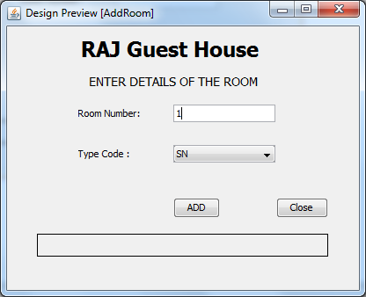

**Form Name: AddRoom.java**

private void AddBActionPerformed(java.awt.event.ActionEvent evt) {

// TODO add your handling code here:

error.setText(" ");

String Rnum = RNumTF.getText();

String Tcode = TCode.getSelectedItem().toString();

try {

Class.forName("java.sql.Driver");

String database = "jdbc:mysql://localhost:3306/Hotal";

Connection conn = DriverManager.getConnection(database, "root", "pace");

Statement stmt = conn.createStatement();

String sql = "Insert into Room values ( '" + Rnum + "','" + Tcode + "')" ;

stmt.executeUpdate(sql);

for(int i=1; i<13;i++) {

String sql2 = "Insert into Status" + i + "(RoomNo, TypeCode) values ( '" + Rnum + "','" + Tcode + "')" ;

Statement stmt2 = conn.createStatement();

stmt2.executeUpdate(sql2);

}

error.setText("Information added");

stmt.close();

conn.close();

} catch (Exception e) { error.setText("Incorrect Entry");}

}

private void jButton1ActionPerformed(java.awt.event.ActionEvent evt) {

// TODO add your handling code here:

this.dispose();

}

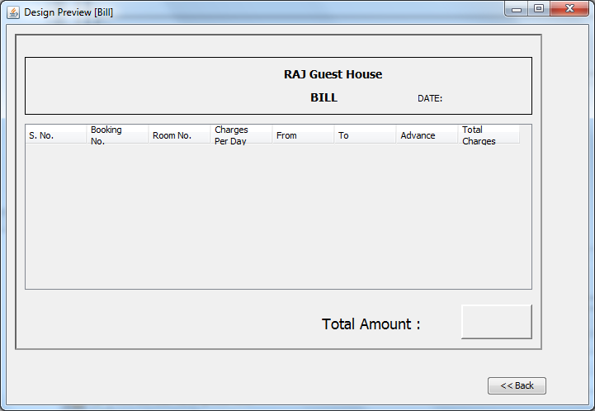

**Form Name: Bill.java**

import java.sql.*;

import javax.swing.table.*;

import javax.swing.JOptionPane;

//import java.util.*;

import java.text.*;

import java.awt.print.*;

public class Bill extends javax.swing.JFrame {

int bookingNo;

/** Creates new form Bill */

public Bill(int bno) {

initComponents();

bookingNo = bno;

java.util.Date D = new java.util.Date();

DateFormat df = DateFormat.getDateInstance(DateFormat.SHORT);

dateLBL.setText(df.format(D));

try {

Class.forName("java.sql.Driver");

String database = "jdbc:mysql://localhost:3306/Hotal";

Connection conn = DriverManager.getConnection(database, "root", "pace");

Statement stmt = conn.createStatement();

String sql = "select * from Booking where BookingNo = " + bookingNo;

ResultSet rs = stmt.executeQuery(sql);

Object[] newrow = new Object[8];

if(rs.next())

{

newrow[0] = "1";

newrow[1] = bookingNo + "";

int rno = rs.getInt("RoomNo");

newrow[2] = rno + "";

newrow[4] = rs.getString("FromD");

newrow[5] = rs.getString("ToD");

newrow[6] = rs.getString("Advance");

int Total = rs.getInt("Total");

newrow[7] = Total + "";

TotalL.setText(Total + " /-");

String sql2 = "select Charges from Room, Type where RoomNo = " + rno + " and Room.TypeCode = Type.TypeCode";

ResultSet rs2 = stmt.executeQuery(sql2);

rs2.next();

newrow[3] = rs2.getString(1);

DefaultTableModel tm = (DefaultTableModel)billTBL.getModel();

tm.addRow(newrow);

}

}

catch (Exception e) { JOptionPane.showMessageDialog(null,"" + e);

}

}

private void BackBTNActionPerformed(java.awt.event.ActionEvent evt) {

// TODO add your handling code here:

new MainMenu().setVisible(true);

this.setVisible(false);

}

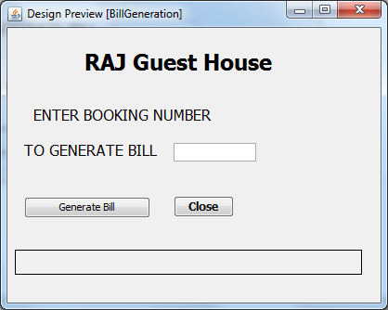

**Form Name: BillGeneration.Java**

private void GenerateBillBTNActionPerformed(java.awt.event.ActionEvent evt) {

// TODO add your handling code here:

int bno = Integer.parseInt( BokingNo4BillTF.getText());

if(search(bno)) {

new Bill(bno).setVisible(true);

this.setVisible(false);

} else {

error2.setText("Unable to fine Booking number");

}

}

private void jButton1ActionPerformed(java.awt.event.ActionEvent evt) {

// TODO add your handling code here:

this.dispose();

}

private boolean search(int bno)

{

try {

Class.forName("java.sql.Driver");

String database = "jdbc:mysql://localhost:3306/Hotal";

Connection conn = DriverManager.getConnection(database, "root", "pace");

Statement stmt = conn.createStatement();

String sql = "select * from Booking where BookingNo = " + bno;

ResultSet rs = stmt.executeQuery(sql);

if(rs.next())

{

return true;

}

else

{

return false;

}

} catch (Exception e) { JOptionPane.showMessageDialog(null,"" + e);

return false; }

}

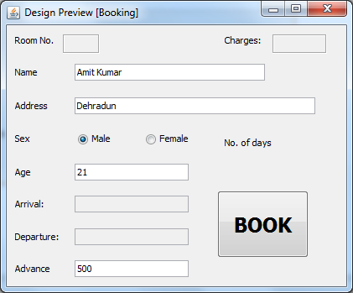

**Form Name: Booking.java**

import java.sql.*;

import java.util.Calendar;

import javax.swing.JOptionPane;

public class Booking extends javax.swing.JFrame {

int stayTime;

int aMonth,dMonth;

int aDay;

int dDay;

int aYear;

int dYear;

/** Creates new form Booking */

public Booking() {

initComponents();

BookingDetailsPart2Panel.setVisible(false);

EnterBookingDetailsPanel.setVisible(true);

String m ="0";

for(int i=1; i<=12; i++)

{

if(i>9)

m="";

Month.addItem(m+ i);

Month1.addItem(m+ i);

}

ContinueBtn.setVisible(false);

}

private void SearchBtnActionPerformed(java.awt.event.ActionEvent evt) {

// TODO add your handling code here:

ReportLBL.setText(" ");

boolean found = false;

ContinueBtn.setVisible(false);

int roomNo=0;

int month = Integer.parseInt(Month.getSelectedItem().toString());

aMonth=month;

int month2 = Integer.parseInt(Month1.getSelectedItem().toString());

dMonth=month2;

int day1 = Integer.parseInt(Date.getSelectedItem().toString());

aDay=day1;

int day2 = Integer.parseInt(Date1.getSelectedItem().toString());

dDay=day2;

int y1 = Integer.parseInt(year.getSelectedItem().toString());

aYear=y1;

int y2 = Integer.parseInt(year1.getSelectedItem().toString());

dYear=y2;

char avail = 'n';

String Tcode = TCode.getSelectedItem().toString();

roomNo = search(month,month2,day1,day2,Tcode);

if(roomNo ==0)

ReportLBL.setText("No Room available.");

else {

ReportLBL.setText("Room No. " + roomNo + " is Available. Click continue to book the room.");

ContinueBtn.setVisible(true);

RNoLBL.setText(roomNo +"");

ArrivalTF.setText(""+y1 +"/"+month + "/" + day1);

DepartureTF.setText(""+y2 +"/"+month2 + "/" + day2);

}

Calendar c = Calendar.getInstance();

c.set(y1,month,day1);

Calendar c2 = Calendar.getInstance();

c2.set(y2,month2,day2);

stayTime = (int)((c2.getTimeInMillis() - c.getTimeInMillis())/(1000*60*60*24));

Stay.setText(""+stayTime);

}

private void MonthItemStateChanged(java.awt.event.ItemEvent evt) {

// TODO add your handling code here:

Date.removeAllItems();

String m="0";

int mon =0,days=0;

int yr = Integer.parseInt(year.getSelectedItem().toString());

if(Month.getSelectedIndex()>=1) {

mon = Integer.parseInt(Month.getSelectedItem().toString());

}

if(mon==2)

if(yr%4 != 0)

days = 28;

else

days =29;

else if( mon==4 || mon ==6 || mon==9 || mon==11)

days = 30;

else

days = 31;

for(int i =1; i<=days ;i++) {

if(i>9)

m="";

Date.addItem(m+i);

}

}

private void Month1ItemStateChanged(java.awt.event.ItemEvent evt) {

Date1.removeAllItems();

String m="0";

int mon =0,days=0;

int yr = Integer.parseInt(year1.getSelectedItem().toString());

if(Month1.getSelectedIndex()>=1) {

mon = Integer.parseInt(Month1.getSelectedItem().toString());

}

if(mon==2)

if(yr%4 != 0)

days = 28;

else

days =29;

else if( mon==4 || mon ==6 || mon==9 || mon==11)

days = 30;

else

days = 31;

for(int i =1; i<=days ;i++) {

if(i>9)

m="";

Date1.addItem(m+i);

}

}

private void ContinueBtnActionPerformed(java.awt.event.ActionEvent evt) {

// TODO add your handling code here:

String code = TCode.getSelectedItem().toString();

try {

Class.forName("java.sql.Driver");

String database = "jdbc:mysql://localhost:3306/Hotal";

Connection conn = DriverManager.getConnection(database, "root", "pace");

Statement stmt = conn.createStatement();

String sql = "select Charges from Type where TypeCode = '" + code + "'";

ResultSet rs = stmt.executeQuery(sql);

rs.next();

int charge = rs.getInt("Charges");

charge = charge * stayTime;

totalChargesLBL.setText(charge+"");

rs.close();

stmt.close();

conn.close();

} catch (Exception e) { }

EnterBookingDetailsPanel.setVisible(false);

BookingDetailsPart2Panel.setVisible(true);

}

private void BookBTNActionPerformed(java.awt.event.ActionEvent evt) {

// TODO add your handling code here:

char gender = 'n';

int month=aMonth;

if(MaleRB.isSelected())

gender = 'm';

else if(FemaleRB.isSelected())

gender = 'f';

int age = Integer.parseInt(AgeTF.getText());

int rno =Integer.parseInt(RNoLBL.getText());

int advance =Integer.parseInt(AdvanceTF.getText());

int tot =Integer.parseInt(totalChargesLBL.getText());

try {

Class.forName("java.sql.Driver");

String database = "jdbc:mysql://localhost:3306/Hotal";

Connection conn = DriverManager.getConnection(database, "root", "pace");

Statement stmt2 = conn.createStatement();

String sql2 = "Select max(BookingNo) from Booking";

ResultSet rs = stmt2.executeQuery(sql2);

rs.next();

int bno = rs.getInt(1)+1;

Statement stmt = conn.createStatement();

String sql = "insert into Booking values (" + bno + ", '" + nameTF.getText() + "' , '" + AddressTF.getText() + "' , '" + gender + "' , "+ age + " , " + rno + " , '" + ArrivalTF.getText() + "' , '" + DepartureTF.getText() + "' , " + advance + " , " + tot + " )" ;

stmt.executeUpdate(sql);

while(month<=dMonth) {

int max=getmax(month,dMonth,dDay);

int min=0;

if(month==aMonth)

min=aDay;

else

min=1;

for(int d=min;d<=max;d++) {

String sql3 = "update status" + month + " set D" + d + " = 'b' where RoomNo = " + rno;

stmt.executeUpdate(sql3);

}

month++;

}

JOptionPane.showMessageDialog(null,"Room booked. Booking number is: "+ bno);

stmt.close();

stmt2.close();

conn.close();

new ReservaTionSlip(bno).setVisible(true);

this.setVisible(false);

} catch (Exception e) { JOptionPane.showMessageDialog(null,"Invalid Data" + e); }

}

private void jButton1ActionPerformed(java.awt.event.ActionEvent evt) {

// TODO add your handling code here:

this.dispose();

}

private int getmax(int month1 ,int month2, int d2)

{

if(month1 == month2)

return d2;

else if(month1 == 2)

return 28;

else if(month1==4 || month1==6 || month1==9 || month1==11)

return 30;

else

return 31;

}

private int search(int month, int month2, int day1, int day2, String Tcode)

{

String avail="f";

boolean found = false;

int rNo = 0;

int max = getmax(month,month2,day2);

try {

Class.forName("java.sql.Driver");

String database = "jdbc:mysql://localhost:3306/Hotal";

Connection conn = DriverManager.getConnection(database, "root", "pace");

Statement stmt = conn.createStatement();

String sql = "select * from Status" + month + " where TypeCode = '" + Tcode + "'";

ResultSet rs = stmt.executeQuery(sql);

while(rs.next())

{

int i;

for(i=day1; i<=max; i++)

{

avail = rs.getString(i+2);

if (avail.equals("b") || avail.equals("o"))

break;

}

if(i == max+1)

{

rNo = rs.getInt(1);

if(month != month2)

found = search2(month+1,month2,1,day2,Tcode,rNo);

else

break;

if(found)

break;

}

}

rs.close();

stmt.close();

conn.close();

} catch (Exception e) { ReportLBL.setText("Incorrect Entry" + e);}

return rNo;

}

private boolean search2(int month1 , int month2,int day1,int day2, String Tcode , int rno)

{

String avail="f";

boolean found = false;

int rNo = 0;

int max = getmax(month1,month2,day2);

try {

Class.forName("java.sql.Driver");

String database = "jdbc:mysql://localhost:3306/Hotal";

Connection conn = DriverManager.getConnection(database, "root", "pace");

Statement stmt = conn.createStatement();

String sql = "select * from status" + month1 + " where TypeCode = '" + Tcode + "' and RoomNo = " + rno;

ResultSet rs = stmt.executeQuery(sql);

rs.next();

int i;

for(i=day1; i<=max; i++)

{

avail = rs.getString(i+2);

if (avail.equals("b") || avail.equals("o"))

break;

}

if(i == max+1)

{

if(month1 != month2)

found = search2(month1+1,month2,1,day2,Tcode,rNo);

else

return true;

}

rs.close();

stmt.close();

conn.close();

} catch (Exception e) { ReportLBL.setText("Incorrect Entry");}

return found;

}

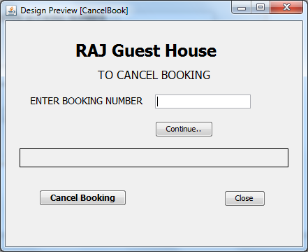

**Form Name: CancelBook.java**

import java.sql.*;

import java.util.Calendar;

import javax.swing.JOptionPane;

private void continueBtnActionPerformed(java.awt.event.ActionEvent evt) {

// TODO add your handling code here:

int bno=0;

if (!BookingNoTF.getText().isEmpty())

bno=Integer.parseInt( BookingNoTF.getText());

try {

Class.forName("java.sql.Driver");

String database = "jdbc:mysql://localhost:3306/Hotal";

Connection conn = DriverManager.getConnection(database, "root", "pace");

Statement stmt = conn.createStatement();

String sql = "select RoomNo, FromD, ToD from Booking where BookingNo = " + bno ;

ResultSet rs = stmt.executeQuery(sql);

if(rs.next()) {

int rno = rs.getInt("RoomNo");

Calendar c = Calendar.getInstance();

Calendar c2 = Calendar.getInstance();

c.setTime(rs.getDate(2));

c2.setTime(rs.getDate(3));

int month1 = c.get(Calendar.MONTH) + 1;

int month2 = c2.get(Calendar.MONTH) + 1;

int day1 = c.get(Calendar.DATE);

int day2 = c2.get(Calendar.DATE);

while(month1<=month2) {

int max=getmax(month1,month2,day2);

int min=0;

if(month1==month2)

min=day1;

else

min=1;

for(int d=min;d<=max;d++) {

String sql3 = "update Status" + month1 + " set D" + d + " = 'f' where RoomNo = " + rno;

stmt.executeUpdate(sql3);

}

month1++;

}

error1.setText("Click continue to genrate calcelation slip");

cancelBtn.setEnabled(true);

} else {

error1.setText("Unable to find booking number");

}

stmt.close();

conn.close();

} catch (Exception e) { error1.setText("Unable to find booking number");

JOptionPane.showMessageDialog(null,"Invalid Data" + e);

}

}

private int getmax(int month1 ,int month2, int d2)

{

if(month1 == month2)

return d2;

else if(month1 == 2)

return 28;

else if(month1==4 || month1==6 || month1==9 || month1==11)

return 30;

else

return 31;

}

private void cancelBtnActionPerformed(java.awt.event.ActionEvent evt) {

// TODO add your handling code here:

int bookingNo =Integer.parseInt( BookingNoTF.getText());

new CancellationSlip(bookingNo).setVisible(true);

this.setVisible(false);

}

private void jButton1ActionPerformed(java.awt.event.ActionEvent evt) {

// TODO add your handling code here:

this.dispose();

}

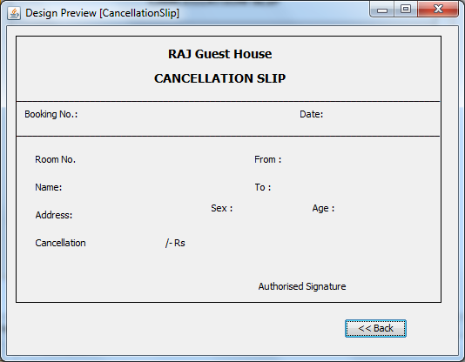

**Form Name: CancellationSlip.java**

import java.sql.*;

import javax.swing.JOptionPane;

import java.text.*;

public class CancellationSlip extends javax.swing.JFrame {

int bookingNo;

/** Creates new form CancellationSlip */

public CancellationSlip(int bno) {

initComponents();

bookingNo =bno;

BNoL.setText(bno + "");

java.util.Date D = new java.util.Date();

DateFormat df = DateFormat.getDateInstance(DateFormat.SHORT);

dateL.setText(df.format(D));

try {

Class.forName("java.sql.Driver");

String database = "jdbc:mysql://localhost:3306/Hotal";

Connection conn = DriverManager.getConnection(database, "root", "pace");

Statement stmt = conn.createStatement();

String sql = "select * from Booking where BookingNo = " + bno;

ResultSet rs = stmt.executeQuery(sql);

if(rs.next())

{

RNoL.setText(rs.getString("RoomNo"));

NameL.setText(rs.getString("CustName"));

AddressL.setText(rs.getString("Address"));

FromL.setText(df.format(rs.getDate("FromD")));

ToL.setText(df.format(rs.getDate("ToD")));

String s = rs.getString("Sex");

if(s.equals("m"))

s = "Male";

else

s = "Female";

SexL.setText(s);

AgeL.setText(rs.getString("Age"));

int tot = rs.getInt("Total");

int fee = (int)(tot * 0.1);

CanL.setText(fee + "");

}

String sqld = "delete from Booking where BookingNo = " + bookingNo;

stmt.executeUpdate(sqld);

stmt.close();

conn.close();

}

catch (Exception e) { JOptionPane.showMessageDialog(null,"" + e);

}

}

private void BackBTNActionPerformed(java.awt.event.ActionEvent evt) {

// TODO add your handling code here:

new MainMenu().setVisible(true);

this.setVisible(false);

}

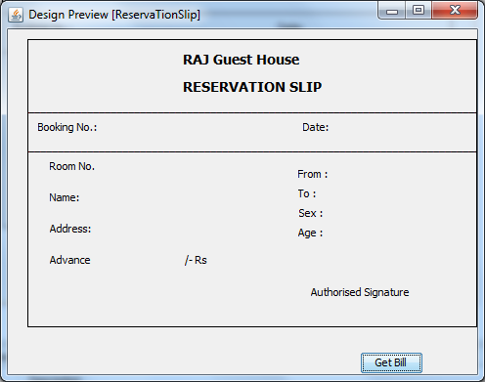

**Form Name: ReservationSlip.java**

import java.sql.*;

import javax.swing.JOptionPane;

import java.text.*;

public class ReservaTionSlip extends javax.swing.JFrame {

int bookingNo;

/** Creates new form ReservaTionSlip */

public ReservaTionSlip(int bno) {

initComponents();

bookingNo = bno;

BNoL.setText(bno + "");

java.util.Date D = new java.util.Date();

DateFormat df = DateFormat.getDateInstance(DateFormat.SHORT);

dateL.setText(df.format(D));

try {

Class.forName("java.sql.Driver");

String database = "jdbc:mysql://localhost:3306/Hotal";

Connection conn = DriverManager.getConnection(database, "root", "pace");

Statement stmt = conn.createStatement();

String sql = "select * from Booking where BookingNo = " + bookingNo;

ResultSet rs = stmt.executeQuery(sql);

if(rs.next())

{

RNoL.setText(rs.getString("RoomNo"));

NameL.setText(rs.getString("CustName"));

AddressL.setText(rs.getString("Address"));

FromL.setText(df.format(rs.getDate("FromD")));

ToL.setText(df.format(rs.getDate("ToD")));

String s = rs.getString("Sex");

if(s.equals("m"))

s = "Male";

else

s = "Female";

SexL.setText(s);

AgeL.setText(rs.getString("Age"));

AdvanceL.setText(rs.getString("Advance"));

}

rs.close();

stmt.close();

conn.close();

}

catch (Exception e) { JOptionPane.showMessageDialog(null,"" + e);

}

}

private void GetBillBTNActionPerformed(java.awt.event.ActionEvent evt) {

// TODO add your handling code here:

new Bill(bookingNo).setVisible(true);

this.setVisible(false);

}

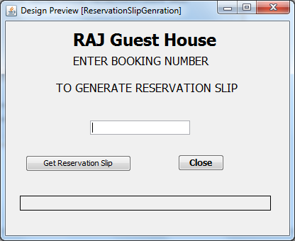

**Form Name: ReservationSlipGeneration.java**

private void GenerateResSlipBTNActionPerformed(java.awt.event.ActionEvent evt) {

// TODO add your handling code here:

int bno = Integer.parseInt( BokingNo4ResSlipTF.getText());

if(search(bno)) {

new ReservaTionSlip(bno).setVisible(true);

this.setVisible(false);

} else {

error1.setText("Unable to fine Booking number");

}

}

private boolean search(int bno)

{

try {

Class.forName("java.sql.Driver");

String database = "jdbc:mysql://localhost:3306/Hotal";

Connection conn = DriverManager.getConnection(database, "root", "pace");

Statement stmt = conn.createStatement();

String sql = "select * from Booking where BookingNo = " + bno;

ResultSet rs = stmt.executeQuery(sql);

if(rs.next())

{

return true;

}

else

{

return false;

}

} catch (Exception e) { JOptionPane.showMessageDialog(null,"" + e);

return false; }

}

private void BokingNo4ResSlipTFActionPerformed(java.awt.event.ActionEvent evt) {

// TODO add your handling code here:

}

private void jButton1ActionPerformed(java.awt.event.ActionEvent evt) {

// TODO add your handling code here:

this.dispose();

}

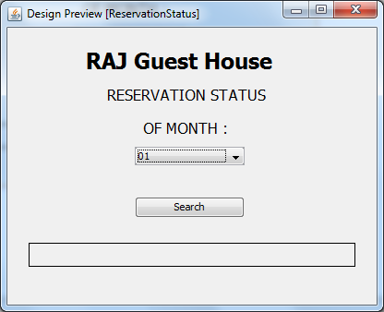

**Form Name: ReservationStatus.java**

public class ReservationStatus extends javax.swing.JFrame {

/** Creates new form ReservationStatus */

public ReservationStatus() {

initComponents();

}

private void SearchBTNActionPerformed(java.awt.event.ActionEvent evt) {

// TODO add your handling code here:

int month = Integer.parseInt(MonthCB.getSelectedItem().toString());

new Status(month).setVisible(true);

//this.setVisible(false);

}

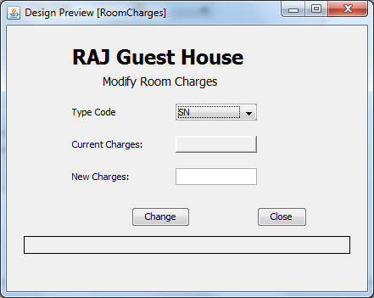

**Form Name: RoomCharges.java**

private void ChangeBActionPerformed(java.awt.event.ActionEvent evt) {

// TODO add your handling code here:

String code = TCode2.getSelectedItem().toString();

int charges =Integer.parseInt( ChargesTF.getText());

try {

Class.forName("java.sql.Driver");

String database = "jdbc:mysql://localhost:3306/Hotal";

Connection conn = DriverManager.getConnection(database, "root", "pace");

Statement stmt = conn.createStatement();

String sql = "update Type set Charges = " + charges + " where TypeCode = '" + code + "'" ;

stmt.executeUpdate(sql);

stmt.close();

conn.close();

error1.setText("Information added");

} catch (Exception e) { error1.setText("Invalid Data");}

}

private void TCode2ItemStateChanged(java.awt.event.ItemEvent evt) {

// TODO add your handling code here:

String code = TCode2.getSelectedItem().toString();

try {

Class.forName("java.sql.Driver");

String database = "jdbc:mysql://localhost:3306/Hotal";

Connection conn = DriverManager.getConnection(database, "root", "pace");

Statement stmt = conn.createStatement();

String sql = "select Charges from Type where TypeCode = '" + code + "'";

ResultSet rs = stmt.executeQuery(sql);

rs.next();

int str = rs.getInt("Charges");

rs.close();

stmt.close();

conn.close();

curCharges.setText("Rs " + str);

} catch (Exception e) { }

}

private void jButton1ActionPerformed(java.awt.event.ActionEvent evt) {

// TODO add your handling code here:

this.dispose();

}

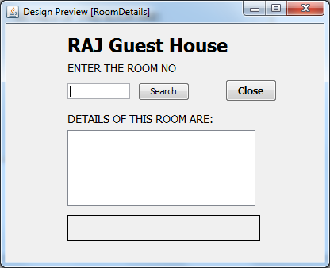

**Form Name: RoomDetails.java**

private void SearchBActionPerformed(java.awt.event.ActionEvent evt) {

// TODO add your handling code here:

int rnum =Integer.parseInt(RNoTF.getText());

try {

Class.forName("java.sql.Driver");

String database = "jdbc:mysql://localhost:3306/Hotal";

Connection conn = DriverManager.getConnection(database, "root", "pace");

Statement stmt = conn.createStatement();

String sql = "select Type.TypeCode, Description, Charges from Type , Room where RoomNo = " + rnum + " and Type.TypeCode = Room.TypeCode";

ResultSet rs = stmt.executeQuery(sql);

rs.next();

String str = rs.getString("TypeCode");

roomDetailsTA.setText(str);

String str1 = rs.getString("Description");

String str2 = rs.getString("Charges");

roomDetailsTA.setText("Room Number :" + rnum + "\nType: " + str + "\nDescription: " + str1 + "\nCharges : " + str2);

rs.close();

stmt.close();

conn.close();

} catch (Exception e)

{ roomDetailsTA.setText("");

error2.setText("Room Number Not Found");}

}

private void jButton1ActionPerformed(java.awt.event.ActionEvent evt) {

// TODO add your handling code here:

this.dispose();

}

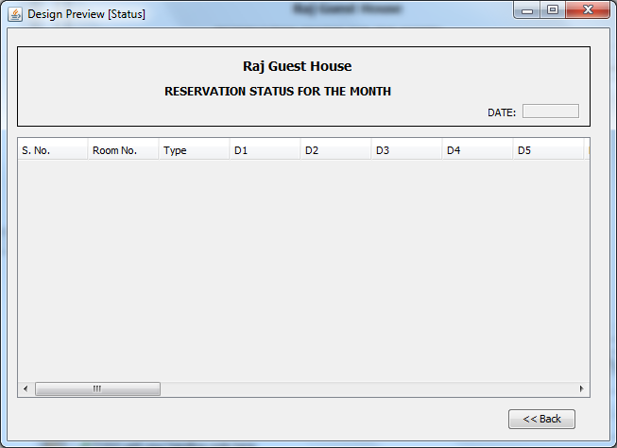

**Form Name: Status.java**

import java.sql.*;

import javax.swing.table.*;

import javax.swing.JOptionPane;

public class Status extends javax.swing.JFrame {

int month;

/** Creates new form Status */

public Status(int m) {

initComponents();

month=m;

int SNo = 1;

jLabel2.setText(jLabel2.getText() + month + "/2011");

dateLBL.setText(month+ "/2010");

try {

Class.forName("java.sql.Driver");

String database = "jdbc:mysql://localhost:3306/Hotal";

Connection conn = DriverManager.getConnection(database, "root", "pace");

Statement stmt = conn.createStatement();

String sql = "select * from Status" + m;

ResultSet rs = stmt.executeQuery(sql);

Object[] newrow = new Object[34];

while(rs.next())

{

newrow[0] = SNo + "";

int max =0;

if(m==2)

max = 28;

else if(m==4 || m==6 || m==9 || m==11)

max=30;

else

max =31;

for(int i=1;i<max+3;i++)

newrow[i]=rs.getObject(i);

for(int j=33;j>max+2;j--)

newrow[j]="-";

DefaultTableModel tm = (DefaultTableModel)statusTBL.getModel();

tm.addRow(newrow);

SNo++;

}

rs.close();

stmt.close();

conn.close();

}

catch (Exception e) { JOptionPane.showMessageDialog(null,"" + e);

}

}

private void BackBTNActionPerformed(java.awt.event.ActionEvent evt) {

// TODO add your handling code here:

new MainMenu().setVisible(true);

this.setVisible(false);

}